**DAILY ONLINE ACTIVITIES SUMMARY**

|  |  |  |  |  |  |  |  |
| --- | --- | --- | --- | --- | --- | --- | --- |
| **Date:** | **26/06/2020** | | | | **Name:** | **Syed Rabeya Aamir** | |
| **Sem & Sec** | **8th B** | | | | **USN:** | **4AL16CS112** | |
| Online Test Summary | | | | | | | |
| **Subject** | | **__** | | | | | |
| **Max. Marks** | | **__** | | **Score** | | **---** | |
| Certification Course Summary | | | | | | | |
| **Course** | **INTRODUCTION TO INFORMATION SECURITY.** | | | | | | |
| **Certificate Provider** | | | **Great Learning** | **Duration** | | | **5.5 hrs** |
| Coding Challenges | | | | | | | |
| **Problem Statement:**  **1) Python Program for How to check if a given number is Fibonacci number?** | | | | | | | |
| **Status: Solved** | | | | | | | |
| **Uploaded the report in Github** | | | | **YES** | | | |
| **If yes Repository name** | | | | **rabeya** | | | |
| **Uploaded the report in slack** | | | | **YES** | | | |

**Certification Course Details:**

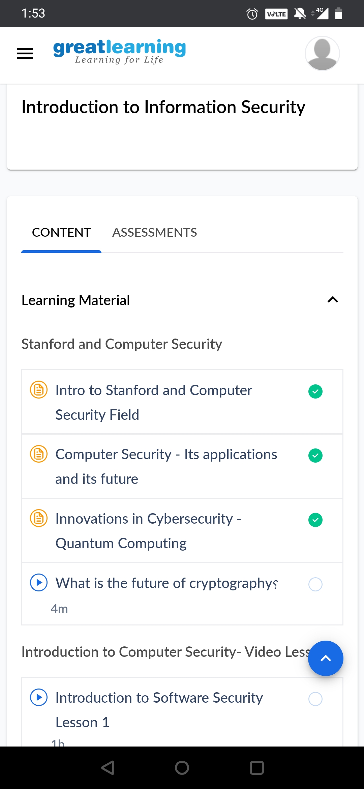

* Computer security, cybersecurity or information technology security (IT security) is the protection of computer systems and networks from the theft of or damage to their hardware, software, or electronic data, as well as from the disruption or misdirection of the services they provide.
* Thesecurity precautions related to computer information and access address four major threats:

(1) theft of data, such as that of military secrets from government computers.

(2) vandalism, including the destruction of data by a computer virus.

(3) fraud, such as employees at a bank channeling funds into their own accounts.

(4) invasion of privacy, such as the illegal accessing of protected personal financial

or medical data from a large database.

* The most basic means of protecting a computer system against theft, vandalism, invasion of privacy, and other irresponsible behaviours is to electronically track and record the access to, and activities of, the various users of a computer system.

# CODE:

Program no:1

# Python Program for How to check if a given number is Fibonacci number?

import math

def isPerfectSquare(x):

s = int(math.sqrt(x))

return s*s == x

def isFibonacci(n):

return isPerfectSquare(5*n*n + 4) or isPerfectSquare(5*n*n - 4)

for i in range(1,11):

if (isFibonacci(i) == True):

print i,"is a Fibonacci Number"

else:

print i,"is a not Fibonacci Number "